|  |  |
| --- | --- |
|  | WSCCPos-25mm |

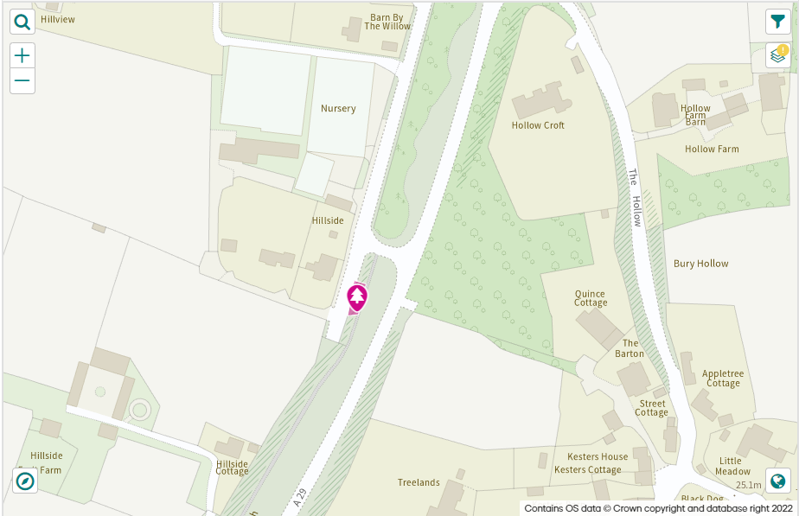21/12/22

Dear Parish Councillors,

We are writing to update you on our ash dieback programme of works.

We will shortly be starting our Ash dieback works which are based on the surveys we carried out this summer, the initial site for the Bury area is in the location indicated in the map below and works are scheduled to take place on the 6th January 2022.

These works will involve the removal of ash trees on the West side of the carriageway.

A further two sites are proposed for works, I will contact you again when I have confirmation of dates for these locations.

Please feel free to share this information accordingly, and if possible please notify residents through appropriate channels available to you.

WSCC Ash Dieback Project Support Officer