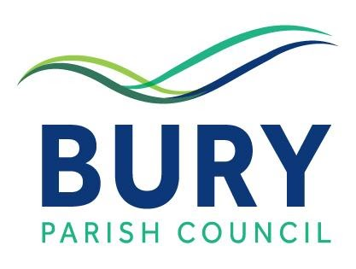

NEWSLETTER 9th MARCH 2022

Dear Parishioner

CORONAVIRUS UPDATE

Vaccination Update

As at 7th March, 52,677,564 people had received a first dose of a coronavirus vaccine (91.6% of the population aged 12 and over) and 49,120,352 people both doses (80.3%). A total of 38,396,473 people had received a booster jab (66.8%).

Spring Booster Jabs

On March 3rd the government announced that people aged 75 years and older, residents in care homes for older people and those with weakened immune systems will be offered a spring booster coronavirus (COVID-19) vaccine (i.e. a fourth jab). Appointments will be available from the National Booking Service shortly. For more information, please see here: -
https://www.gov.uk/government/publications/covid-19-vaccination-spring-booster-resources/a-guide-to-the-spring-booster-for-those-aged-75-years-and-older-residents-in-care-homes

NHS Covid Pass

The government have produced updated guidance on the use of the NHS COVID Pass to demonstrate your coronavirus (COVID-19) status when travelling abroad and domestically at venues and settings in England. Although since 27th January it is no longer mandatory for venues to require attendees to demonstrate their COVID-19 status, some venues or events may still choose to require proof of COVID-19 status as a condition of entry. For further details please see here: -

https://www.gov.uk/guidance/nhs-covid-pass?utm_medium=email&utm_campaign=govuk-notifications-topic&utm_source=4a9ba64b-b91b-4dbe-b0e4-975531949d71&utm_content=daily

BURY PARISH COUNCIL

Environment & Planning Committee Meeting

The draft minutes of the meeting of the Environment & Planning Committee held on 21st February have now been posted on the BPC website and the notice boards and can also be accessed here: -
EP-Minutes-21st-February-2022.pdf (buryparishcouncil.org.uk)

Parish Councillor Vacancy

There is currently a vacancy for one position available on Bury Parish Council, presenting the opportunity to join with the eight current councillors to work in the interests of our residents and protect the identity and character of the parish for the enjoyment of parishioners and visitors alike. Further information is provided in the notice now appearing on the noticeboards and which can also be accessed here: - Vacancy Notice - March 2022.pdf

Please note that applications should reach the Council by 14th March 2022.

Bury Parish Council – Next Meeting

The next meeting of Bury Parish Council will be held on Wednesday 23rd March in Bury Village Hall commencing at 7.30pm. Further details including the agenda for the meeting will be provided nearer the date.

Pill Pond, West Burton

Plans to turn Pill Pond into a natural watercourse are currently under ongoing discussion with the Chichester District Council watercourse team and the SDNPA as part of the planning application process. In the meantime, the SDNPA ranger has provided Bury Parish Council with an artist’s impression following re-naturalisation of the location in question should the project proceed.

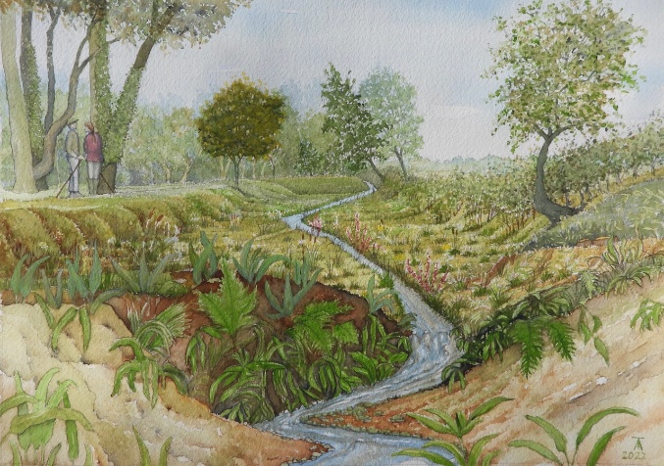

HORTICULTURAL SOCIETY SPRING SHOW – SATURDAY 19TH MARCH

A reminder that the Bury, West Burton and District Horticultural Society will be holding its Spring Flower Show 2022 on Saturday 19th March in Bury Village Hall. In addition to the usual horticultural exhibits, the show will include sections on cookery, handicrafts, flower arranging, art and photography plus children’s exhibits. Entry forms can be found in the Society’s printed programme which was distributed recently. The programme can also be viewed on the Bury Parish Council website – please see here: - https://buryparishcouncil.org.uk/wp-content/uploads/2022/02/Hort-Soc-Prog-2022-final.pdf

Please submit completed entry forms to chrisgflower@gmail.com or hand deliver to Chris Flower, High Dyke, Church Lane, Bury RH20 1PB by Thursday 17 March 2022. Entrance to the village hall for staging exhibits will take place on the morning of the show between 9.30 and 10.45am.

The hall will be open from 3pm to 4pm for viewing of the exhibits and presentation of prizes – refreshments will be available along with the opportunity to win a prize in the raffle. The Horticultural Society look forward to welcoming exhibitors and visitors alike on the 19th and if you would like further information about the Horticultural Society and its events for this year, please contact Gill Labarte by phone on 01798-831174 or email her at gill.labarte@btinternet.com

CHICHESTER DISTRICT COUNCIL

Council Tax for 2022/23

CDC are due to issue council tax bills for 2022/23 to residents on 14th March. You can view your bill for 2022/23 on the CDC website now but you will need to create an online council tax account to do so. For more information, please see here: - Council tax bills: Chichester District Council

Energy Bills Rebate

Most Council Tax payers in houses in tax bands A to D will receive a one-off payment of £150 to support households with rising energy bills. For further details, please see here: - https://www.chichester.gov.uk/energybillsrebate2022

CHICHESTER FESTIVAL THEATRE

CFT are celebrating their diamond anniversary this year and have now published their programme for 2022 which includes six world premiere productions, three musicals and a host of dramas in addition to a roster of community and digital events celebrating their 60 years history. Full details can be seen here: -
https://cftmail.org.uk/31LM-193BB-E687521136C2B55D27B4X87D480FF2964B9FCA/cr.aspx

DVLA UPDATE

For an update on the timescales for processing driving licence applications and other documentation by the DVLA please see here: -
https://www.gov.uk/guidance/dvla-coronavirus-covid-19-update?utm_medium=email&utm_campaign=govuk-notifications-topic&utm_source=da7c257b-e097-4eb7-a7bd-b733eea29313&utm_content=daily

WEST SUSSEX LIBRARIES SERVICE

The following extract from an update from the Libraries Service may be of particular interest to any library users who have yet to return overdue books for which late return fees have not been charged due to the pandemic.

Time to find and return those overdue books!
Has it been a while since you visited the library? We’d love to see you! Have you still got items on loan? These can be returned to your local library and, if you can’t make it while we're open, many of them have large letterboxes available for returning your loans out of hours.
Have you had the books out for a long time? At the moment – due to the pandemic – we aren’t charging any late return fees. But our overdue, reservation and hire charges will be returning from 1 April so, if you can get the books back to us before the end of March, you don’t need to worry about owing us anything.
If you are worried about any future overdue charges you can sign up for pre-overdue notifications so you can renew your loans ahead of time. Don't forget that you can renew your loans online, or by using our West Sussex Libraries app (available from your app store).

For further information please contact the parish clerk, Mike Simpson, at clerkburyparishcouncil@gmail.com

To visit the parish council website, please see: - www.buryparishcouncil.org.uk

Best wishes
Bury Parish Council

