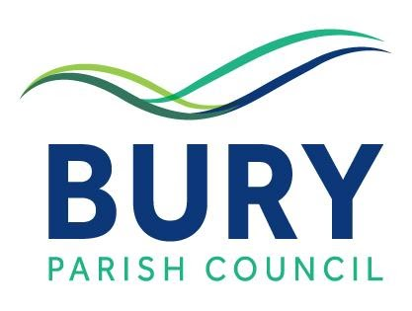

NEWSLETTER 1st DECEMBER 2021

Dear Parishioner

CORONAVIRUS UPDATE

Vaccination Update

As at 29th November, a total of 97,330,867 doses of a coronavirus vaccine had been administered in the UK, with 50,963,718 people receiving a first dose (88.6% of the population aged 12 and over) and 46,367,149 people receiving both doses (80.6%). A total of 18,215,535 people had received a booster jab (31.7%).

New COVID-19 Omicrom Variant

Temporary and precautionary measures (to be reviewed after three weeks) to prevent the spread of the new COVID-19 Omicron variant in the UK have come into force in England in recent days as follows: -

- Face coverings are now compulsory in shops, supermarkets and a number of other settings such as banks, post offices and hairdressers, as well as on public transport, unless individuals are exempt from wearing them. This does not apply to hospitality venues such as pubs, restaurants, bars etc. Further details of the rules on face coverings and the settings in which they must now be worn can be seen here: - https://www.gov.uk/government/publications/face-coverings-when-to-wear-one-and-how-to-make-your-own?utm_medium=email&utm_campaign=govuk-notifications&utm_source=3060e28f-ba37-48fd-9fc5-e3818fbac33a&utm_content=daily

- All close contacts of anyone who has tested positive for the Omicron variant are required to isolate for 10 days regardless of whether they have been vaccinated.

- Pupils in Year 7 and above in England are strongly advised to wear face coverings in communal areas. The guidance also applies to staff and visitors at all schools and childcare settings

- The Booster Jab programme is to be extended and accelerated– everyone aged 18 and over will now be offered a booster jab with the gap between the second and third jabs being reduced from six months to three. All those eligible for a booster will be offered a jab by the end of January and will be prioritised according to age with the NHS working down the list in five-year bands. The Prime Minister said that England will have more than 1,500 community pharmacy sites and around 400 military personnel to help with the rollout. The severely immunosuppressed will now be offered a fourth jab. Children aged 12 to 15 will now be offered a second dose three months after the first.
.
- All travellers arriving in England are now required to take a PCR test on or before day 2 and self -isolate until they have received a negative test result. These PCR tests can be purchased from private providers. Free NHS tests are not valid for this purpose. For more details please see here: - https://www.gov.uk/guidance/travel-to-england-from-another-country-during-coronavirus-covid-19?utm_medium=email&utm_campaign=govuk-notifications&utm_source=5d99c957-5b87-4930-a32a-4b3c7f32f84f&utm_content=daily .
Not surprisingly, other countries have reacted in similar fashion to the new Omicrom variant and a number have imposed tougher border restrictions for visitors, including some of the most popular holiday destinations at this time of year such as Spain, Portugal, Switzerland and Morocco. If you are planning a trip abroad, the latest advice about foreign travel including information on coronavirus, safety and security, entry requirements and travel warnings for various countries can be found here: - https://www.gov.uk/foreign-travel-advice

- The following countries have now been placed on the Red List for international travel purposes for which special rules apply – Angola, Botswana, Eswatini, Lesotho, Malawi, Mozambique, Namibia, South Africa and Zimbabwe. Full details can be found here: - https://www.gov.uk/guidance/red-list-of-countries-and-territories

Private Test Providers

If you need to arrange a private Covid-19 test, the government’s latest list of test providers can be found here: -

https://www.gov.uk/government/publications/list-of-private-providers-of-coronavirus-testing?utm_medium=email&utm_campaign=govuk-notifications&utm_source=12ef3ca2-7c52-4da6-a8a5-e34237f96cd8&utm_content=daily

BURY PARISH COUNCIL

Planning Applications/Decisions

Planning applications received by Bury Parish Council in its role as a consultee can always be seen on our website and can also be accessed here: - Planning Application Decisions – Bury Parish Council
To see all supporting documents in connection with an application submitted to the South Downs National Park Authority – the local planning authority – click on the link to the SDNPA website and use the reference number for the application in question.
COFFEE MORNING – Saturday 4th December

A reminder that our monthly coffee mornings are set to resume this Saturday 4th December in Bury Village Hall commencing at 10.30am.

Please note that the wearing of face coverings is not mandatory inside village and community halls although government guidance recommends their continued use in confined spaces such as on arrival, leaving and when using communal areas such as corridors and toilets - but where food or drink is consumed in part of a premises, you do not need to wear a face covering in the area wholly or mainly used for eating and drinking. In accordance with hygiene requirements under our COVID-19 risk assessment, all tables, chairs, door handles etc, will have been disinfected before use and hand sanitisers will be placed in various locations throughout the building. Tables will be sited with reasonable distance between them and adequate ventilation provided.
We look forward to seeing you there and please contact John Labarte on 831174 if you require any further information.
THE BURY CHRISTMAS TREE - Help Wanted!
Once again, we have a splendid Christmas tree proudly standing outside the village hall – and another inside - but Judith Daykin, our hall manager, urgently needs help to decorate them – are you free to help Judith on Friday 3rd December between 10.00am and 12 noon please? If you are available, please email Judith as soon as possible at vhmanager@buryparishcouncil.org.uk

THE BURY CHRISTMAS CAROL SINGING GET-TOGETHER 16TH DECEMBER
The Bury & West Burton Volunteers are organising their next social event in the run up to Christmas – a Carol Singing Get-Together in Bury Village Hall on Thursday 16th December from 12 noon until 2.30pm. As you will see from BWBV’s invitation, the entry fee of £5 includes a glass of wine along with some quiche and mince pies.
Numbers do have to be limited to 60 on this occasion so it’s first come, first served!
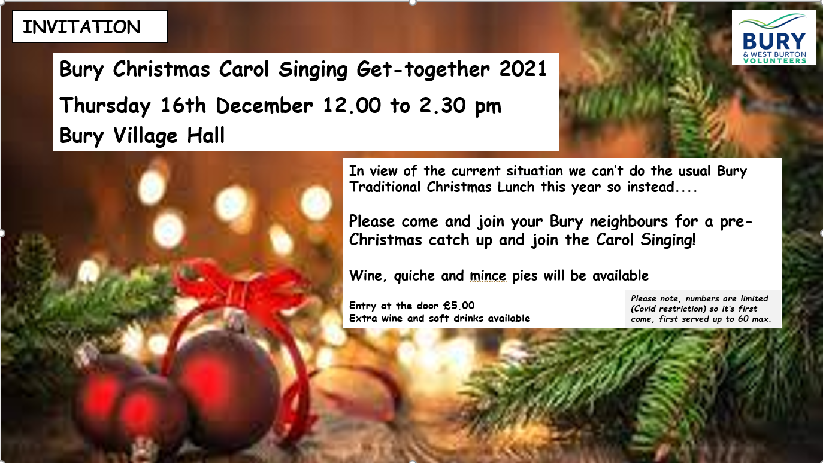
CHICHESTER DISTRICT COUNCIL
Countdown to Christmas
CDC’s Countdown to Christmas campaign encourages everyone to support local businesses and among the many initiatives is a package of car parking incentives during December and an online events and activities calendar. Full details can be found here: - https://www.chichester.gov.uk/countdowntochristmas
Waste & Recycling Dates
During the Christmas and New Year period, the dates for collection of waste and recycling bins are usually subject to alteration so the easiest way to check how you might be affected is to view your personal collection calendar on the CDC website which can be accessed here: - https://www.chichester.gov.uk/wastecollectioncalendar
CDC advise that if you have any extra waste over the holiday period, your collection crews will pick this up on your first collection after Christmas. If you have extra recycling you are asked to keep it dry and place it in a loosely tied black sack next to your recycling bin on your scheduled collection day. The garden waste recycling service will cease from Friday 17th December and resume on Monday 3rd January 2022. You can recycle a real Christmas tree by placing it next to your green bin when collections resume.
WEST SUSSEX CHARGEPOINT NETWORK
As more and more electric vehicles take to the roads, West Sussex will need many more accessible EV chargepoints to meet the increasing demand. To address this, Connected Kerb, West Sussex County Council, Adur and Worthing District Councils, Arun District Council, Crawley Borough Council, Horsham District Council and Mid Sussex District Council have formed a partnership designed to provide a chargepoint network across West Sussex to give residents the confidence to go electric in time for the ban of the sale of new petrol and diesel vehicles in 2030.
To help plan for the new network, residents’ views are being sought as to where chargepoints should be located. Further information and the chance to have your say can be found here: -
https://www.connectedkerb.com/west-sussex-chargepoint-network

For further information please contact the parish clerk, Mike Simpson, at clerkburyparishcouncil@gmail.com

To visit the parish council website, please see: - www.buryparishcouncil.org.uk

Best wishes
Bury Parish Council

