Pill Pond - West Burton Stream
Project proposal January 2021
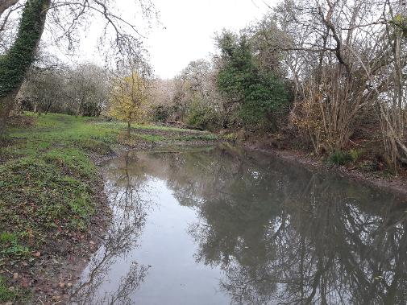

By A Thomas
Email: athomas@wildtrout.org Tel :07876525499

- Introduction

The West Burton Stream is a small chalk-based stream that rises from the northern flank of the South Downs just to the South of Bignor. The stream skirts to the south of West Burton, before dropping into the tidal river Arun at Bury, just three km from its perennial source.
The request for the visit came from South Downs National Parks Ranger Charles Winchester. Charles is particularly interested to explore options for the sustainable management of a small on-line pond that straddles the stream at Ordnance survey National Grid Reference SU99491399.
Comments in this report are based on observations made during a walk-over survey. Normal convention is applied with respect to bank identification, i.e. left bank (LB) or right bank (RB) whilst looking downstream. Upstream and downstream references are often abbreviated to u/s and d/s, respectively, for convenience. The Ordnance Survey National Grid Reference system is used for identifying specific locations.
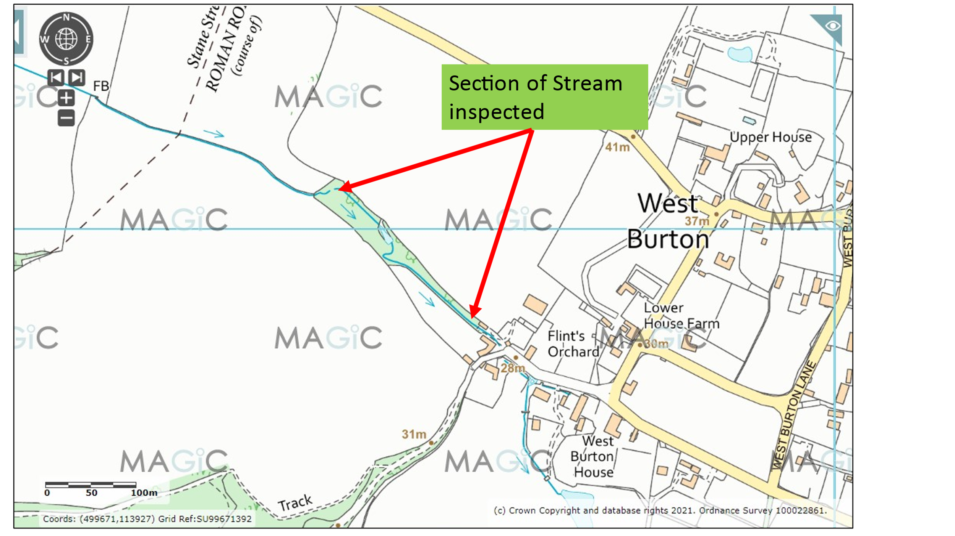
Map 1. West Burton Stream
- Catchment Overview
The Bury Stream is one of a network of small chalkstreams that drain off the northern flanks of the South Downs, where the unusual combination of the underlying chalk geology, coupled with the steep bed gradient characterise them as valuable ecosystems.
The rare and unusual ecology of these streams was only comparatively recently identified by the late Dr. Nigel Holmes in a survey and report commissioned by the Environment Agency (N Holmes: An Investigation of the Watercourses in Sussex arising from the Chalk Aquifer of the South Downs. Report 1 January 2009 and Report 2 December 2010).
Very few of these small chalkstreams have been the subject of detailed biological surveys and the natural flora and fauna they support has never been captured in any comprehensive reports. Most are thought to support wild trout Salmo trutta populations and these populations are likely to be strongly linked to the Arun and Rother population of migratory sea trout, which colonised these streams following the last ice age; sometimes leaving relict populations of resident brown trout in reaches that are now isolated by the construction of ancient mills and dams. Sea trout migrate up from the tidal Arun and Western Rother to utilise these streams for spawning but access on many is severely restricted by numerous man-made structures.
- Habitat Assessment
3.1 Stream
Only a comparatively short section of the stream was inspected, with the main emphasis of the site visit being to evaluate options for managing the Pill Pond.
For much of its length, the stream runs via a comparatively straight route through a very narrow wooded corridor, bordered by meadows. The stream bed is mainly flint and chert gravels, with fine marle sediment deposits in marginal zones and on the inside of gentle bends. The bed slope is comparatively steep, providing the stream with energetic flow velocities and manifesting as long shallow riffles.
The stream has obviously been realigned in many sections. A particular feature of these Sussex chalkstreams is the presence of hearts tongue ferns Asplenium scolopendrium (photo 1) that are frequently found lining the margins, especially in shaded sections. Clumps of pendulous sedge Carex pendula (photo 2) were also evident and both plants provide attractive and biologically valuable flora in the toe of the banks.
A quick inspection of the stream bed revealed that areas of gravel were bound together with tufa, calcium carbonate precipitate that is common in these streams, especially when the source water is so close to the chalk. This can pose difficulties for gravel-spawning fish species and it is important that streams like this contain lots of fallen woody material to help break up flow patterns and keep the bed materials mobile.
Downstream of the Pill Pond, the stream runs adjacent to the footpath and has been recently revetted with vertical wooden toe boarding (photo 4). Habitat quality within the stream is adversely impacted by the toe boarding and it is highly likely that the stream will continue to undermine the bank behind the boards, inevitably leading to failure and expensive repairs to the foot path. Options to divert the stream away from the route of the footpath and re-establish a more sinuous channel with natural margins should be considered in any future maintenance work.
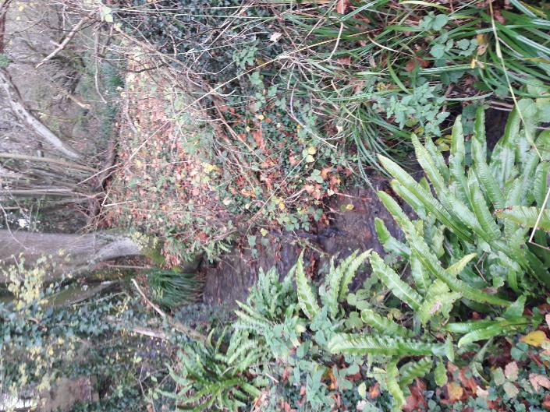
Photo 1. Shallow riffle habitat with a fringe of hearts tongue fern.

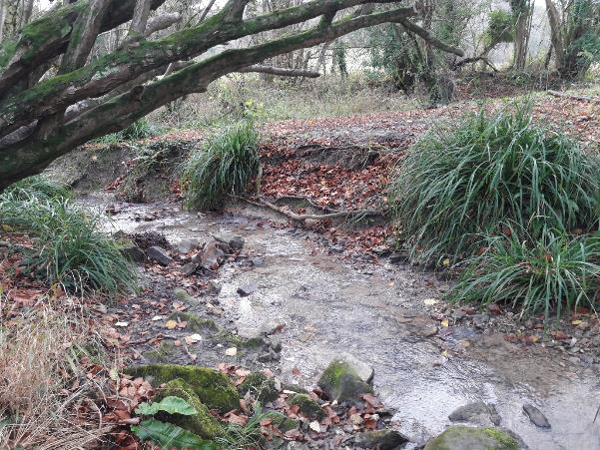
Photo 2. A section below the outlet of the Pill Pond with clumps of Carex providing some protection from bank erosion.
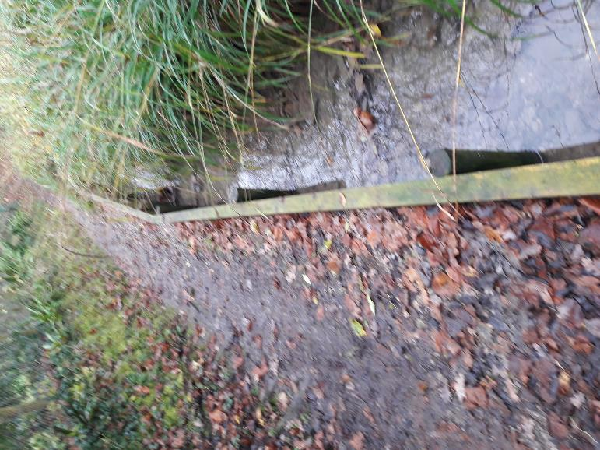
Photo 3. The revetted footpath and toe-board lined margin is likely to fail within a few years and future solutions should explore options for restoring a more natural channel away from the path and establishing resilient, natural and biologically rich stream margins.

  - Pill Pond
The Pill Pond has been created by damming the course of the stream. There is a capped pipe in the toe of dam (photo 4), which may have been used as an offtake for an old ram pump, or possibly installed to help with draining down the pond for maintenance work. There are also drop boards, designed to regulate pond water levels but due to leakage under the dam the structure is failing to maintain levels. This inability to hold a constant pond level has resulted in a poorly established marginal zone, where instead of a defined line of emergent plants, there is just exposed mud (photo 5).
On-line ponds such as this are known sediment traps and have only a very limited life span in between expensive desilting operations. The fact that the dam is also leaking at the base means that it is in danger of complete failure. A more sustainable option would be to take the pond off-line, so that the course of the stream can pass the majority of the flow, plus the suspended sediment loads around any developed pond feature. A perfectly functioning pond could be created adjacent to a new enhanced, stream course and fed with a balancing pipe to maintain levels. The design will require any restoration of a stream channel to have a series of low, naturalistic rock-ramp impoundments in order to retain a head of water to maintain pond levels.
so that sufficient head can be generated to maintain a single balancing pipe to maintain the new off-line pond water levels. The low weirs must not impound water levels by more than a maximum of 200 mm each. A schematic sketch for a possible solution is set out in drawing 1.
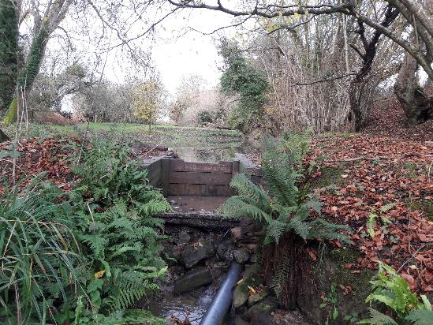
Photo 4. Leaking dam and sluice with capped pipe and drop boards.

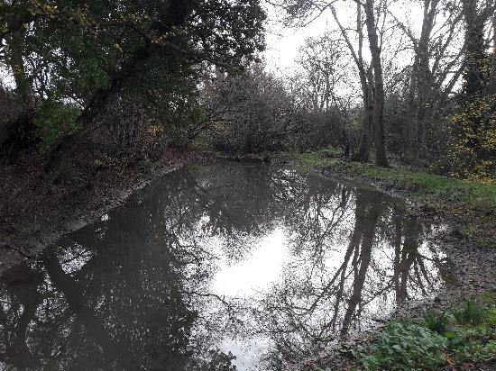
Photo 5. Pond looking down to the dam. Note the exposed pond margins due to unstable water levels.
4.0 Conclusions
The configuration of the pond and the modifications to the stream create major problems for both. A more sustainable and biologically diverse environment could be achieved by restoring a natural course for the stream and taking the pond off-line to reduce sedimentation.
The estimated budget for constructing the new off line pond and a new stream bank-line would be in the order of £20,000. There is the option of re-routing the footpath between the new pond and the stream. The advantages of the design set out in drawing 1 below, is that the existing dam can be demolished, and the new impounded end of any newly constructed pond created with spoil excavated from on site.
Without a constant “flow” passing through the pond, there is much less chance of water finding a pathway through any newly created embankment. Off-line line ponds will still require periodic maintenance work but the requirements for expensive de-silting are likely to be far less frequent and onerous.
Off-line ponds with stable water levels often have a rich flora and fauna associated with “still” water. Whereas small on-line ponds broadly have a similar biology to the stream. The result of having both a connected flowing stream, adjacent to a non-flowing still water habitat is likely to increase opportunities for biodiversity.

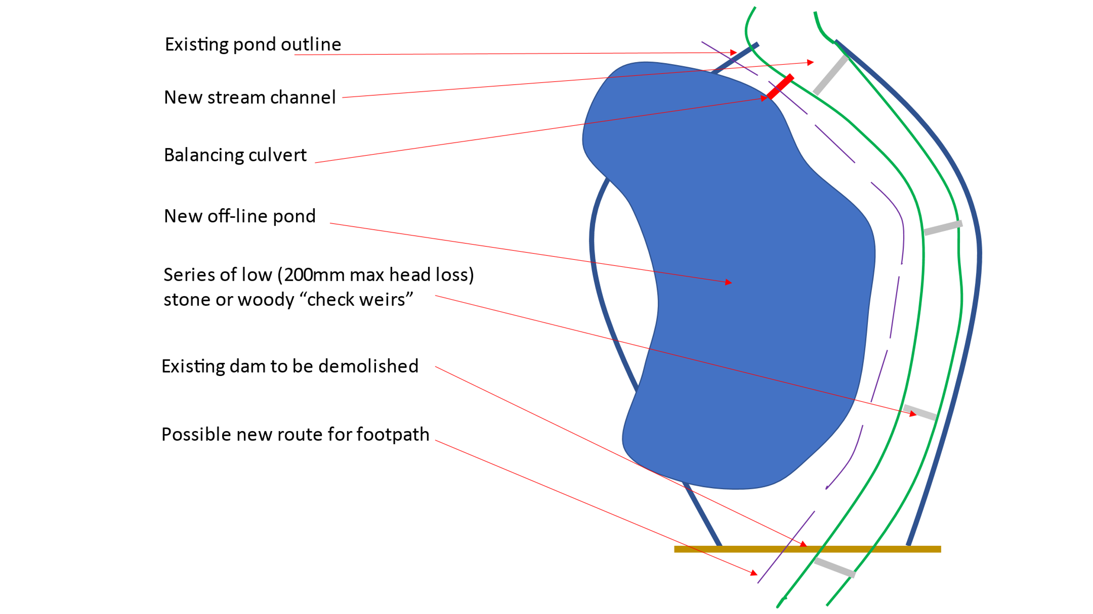
Drawing 1. Schematic drawing for an alternative, more sustainable pond and stream channel.

Making it Happen

Further assistance from the Wild Trout Trust is available in the form of:
Helping obtain the necessary consents for carrying out in-stream works, from either the Environment Agency, for ‘Main River’, or in the case of the stream being designated as “Ordinary Watercourse”, from the local authority.

The WTT website library has a wide range of free materials in video and PDF format on habitat management and improvement:
www.wildtrout.org/content/library
The Wild Trout Trust has also produced a 70-minute DVD called ‘Rivers: Working for Wild Trout’ which graphically illustrates the challenges of managing river habitat for wild trout, with examples of good and poor habitat and practical demonstrations of habitat improvement. Additional sections of film cover key topics in greater depth, such as woody debris, enhancing fish stocks and managing invasive species.
The DVD is available to buy for £10.00 from our website shop www.wildtrout.org/shop/products/rivers-working-for-wild-trout-dvd or by calling the WTT office on 023 9257 0985.

Acknowledgement
The WTT would like to thank the Environment Agency for supporting the advisory and practical visit programme in England, through a partnership funded using rod licence income.

Disclaimer
This report is produced for guidance; no liability or responsibility for any loss or damage can be accepted by the Wild Trout Trust as a result of any other person, company or organisation acting, or refraining from acting, upon guidance made in this report. Accordingly, no liability or responsibility for any loss or damage can be accepted by the Wild Trout Trust as a result of any other person, company or organisation acting, or refraining from acting, upon comments made in this report.

